**Practice Project**

**ASP.NET WebForms**

**Aim:**

To Create an ASP.NET WebForms Application to Display the UI for Managing the School Database

**Github link:**

[**https://github.com/Sukirthalakshmanan1/WebApplication4**](https://github.com/Sukirthalakshmanan1/WebApplication4)

**Procedure:**

* Create an ASP.NET Web application and select web forms.
* Create a master page and add the design
* Create tables student,class,subjects and connect to the database using connection string.
* Create a Web form with master page and add the necessary labels,textboxes and buttons,images.
* Perform Insert,delete,update,search and display all operations in student ,class, subjects tables.
* Grid view is used to display the table
* Label helps to display the messages.

**Output:**

**Home Page:**

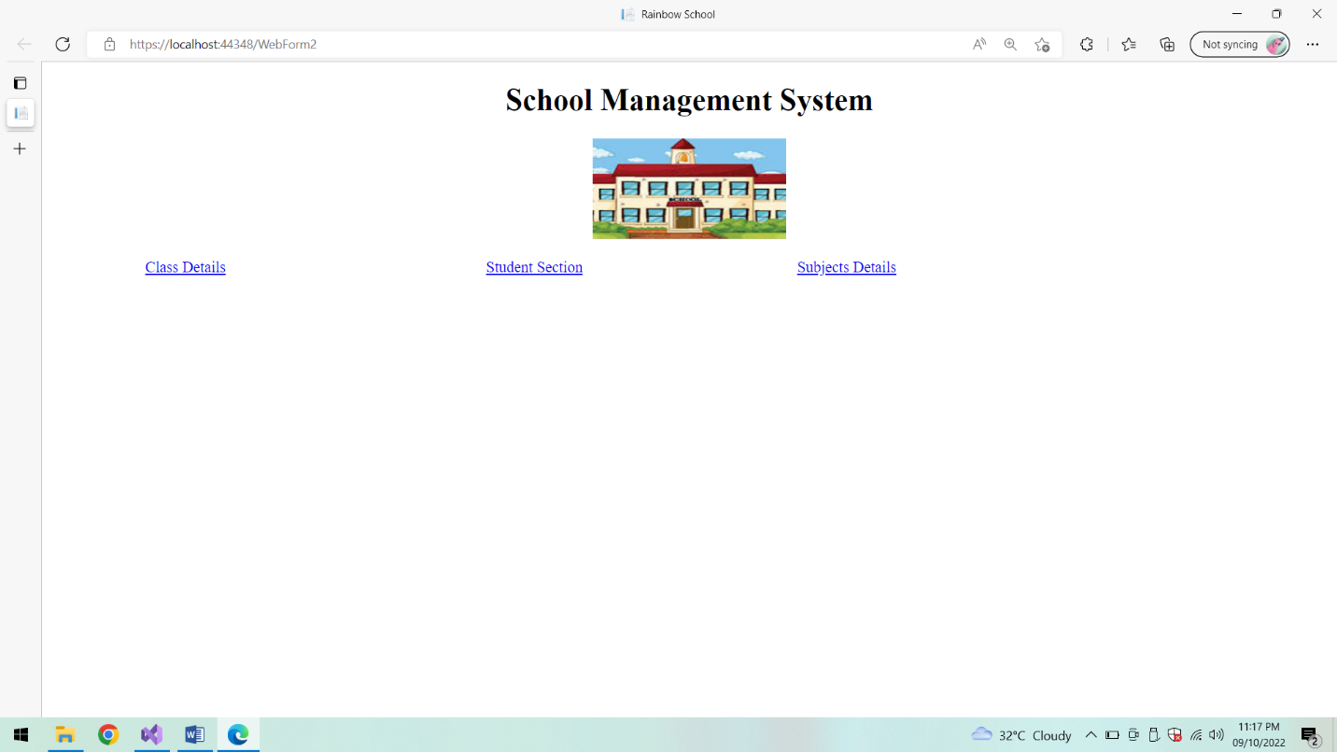

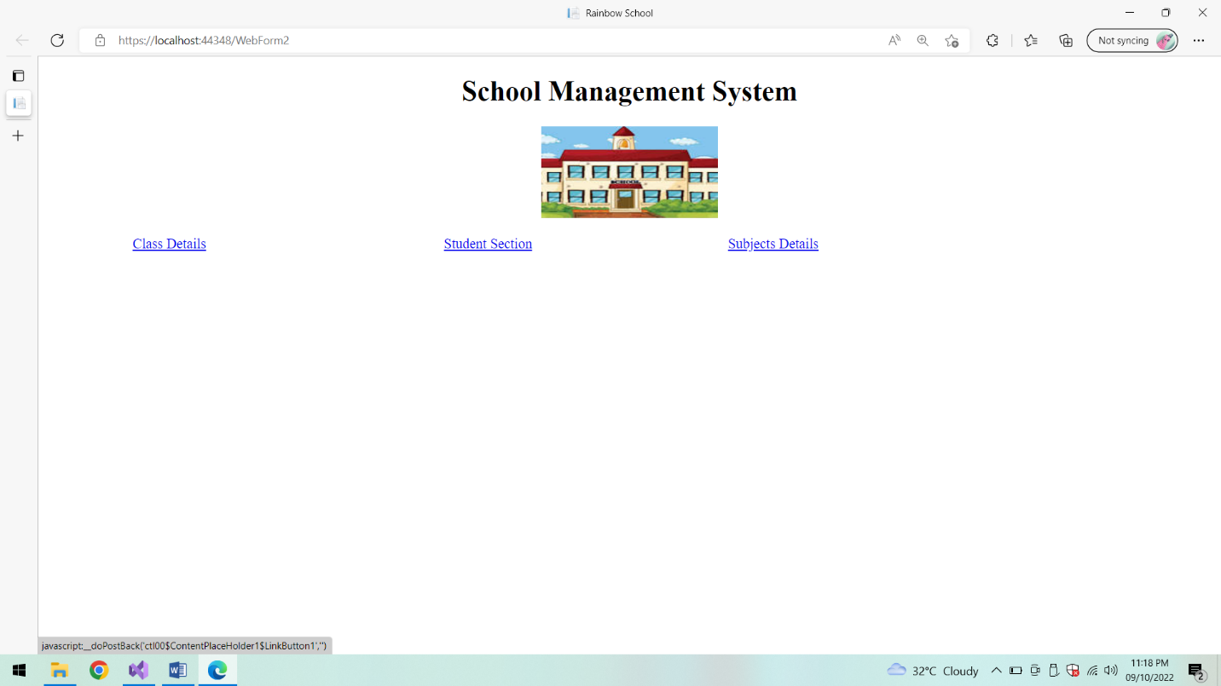

**Class Section:**

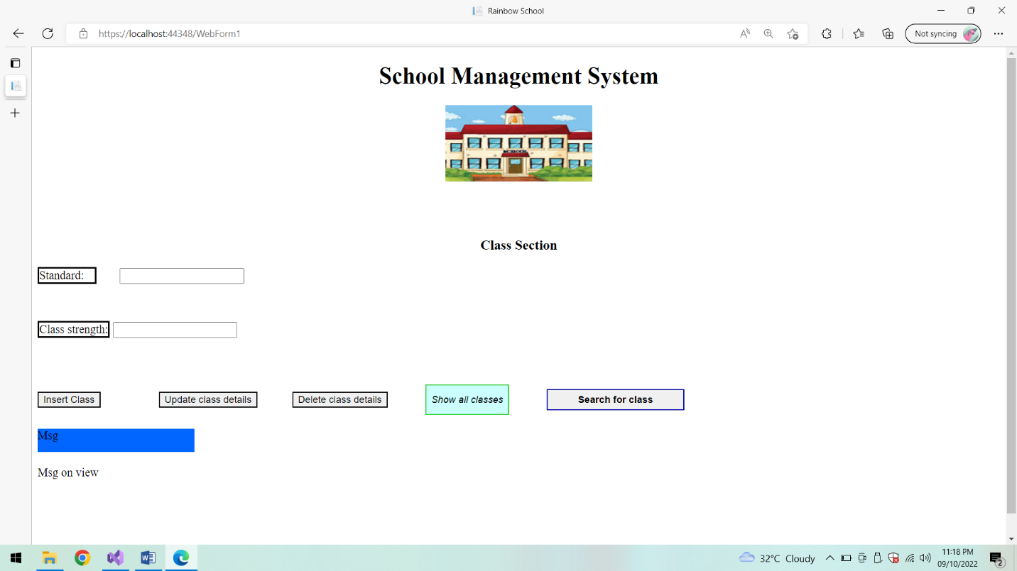

**Show All classes:**

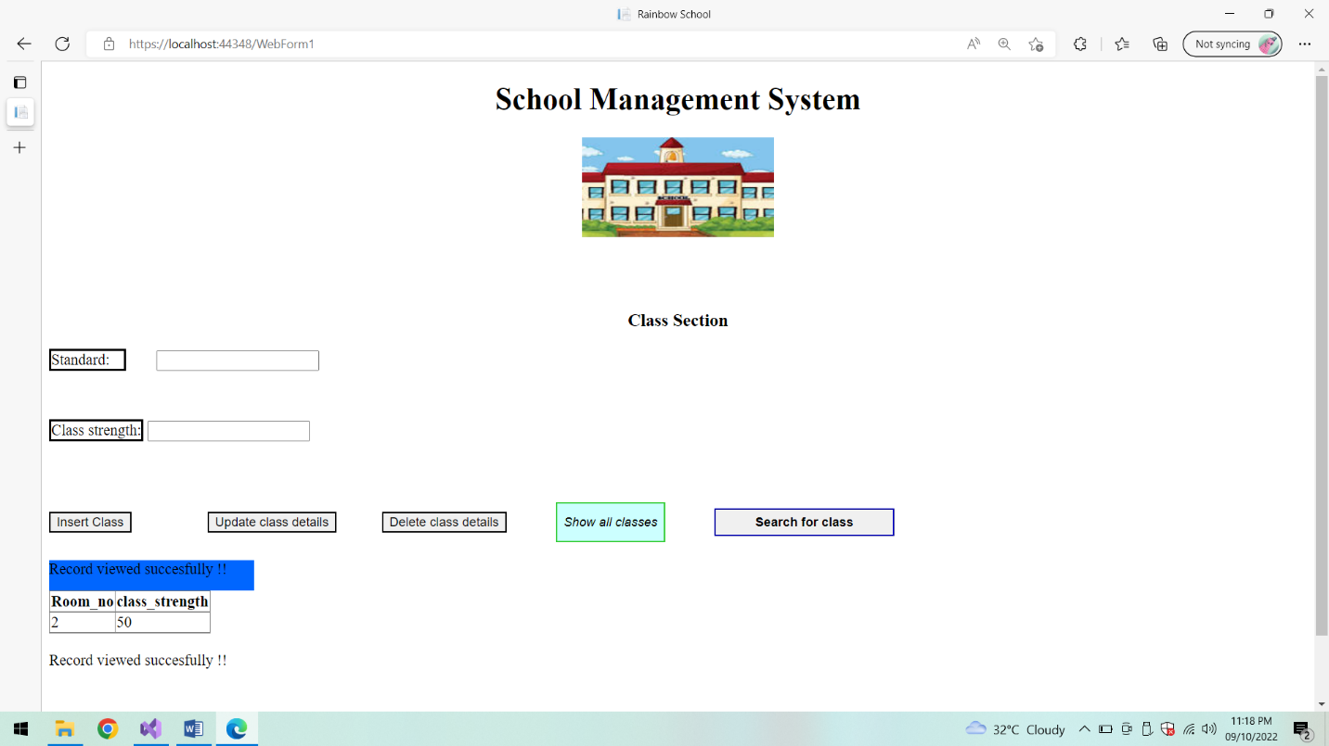

**Insert class:**

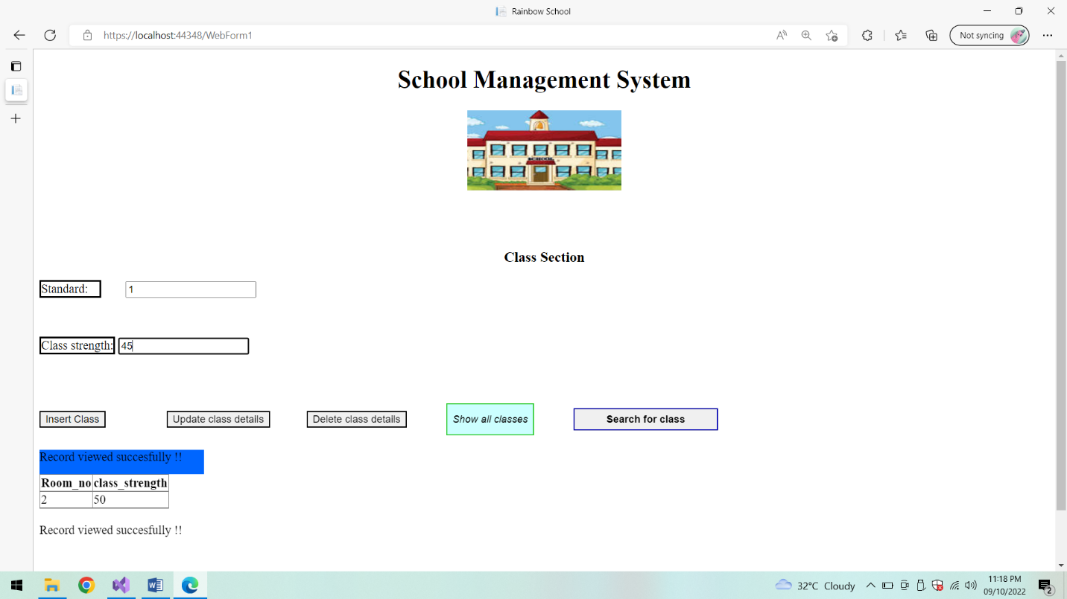

**Class Inserted Successfully and Viewed using Grid view :**

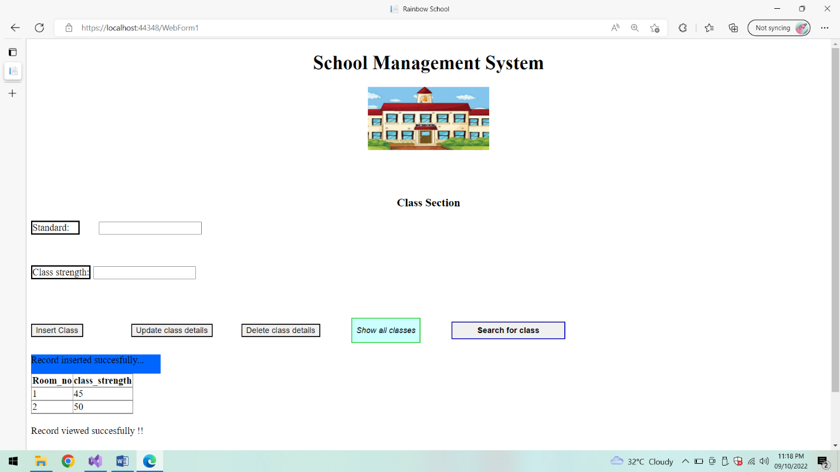

**Update class details:**

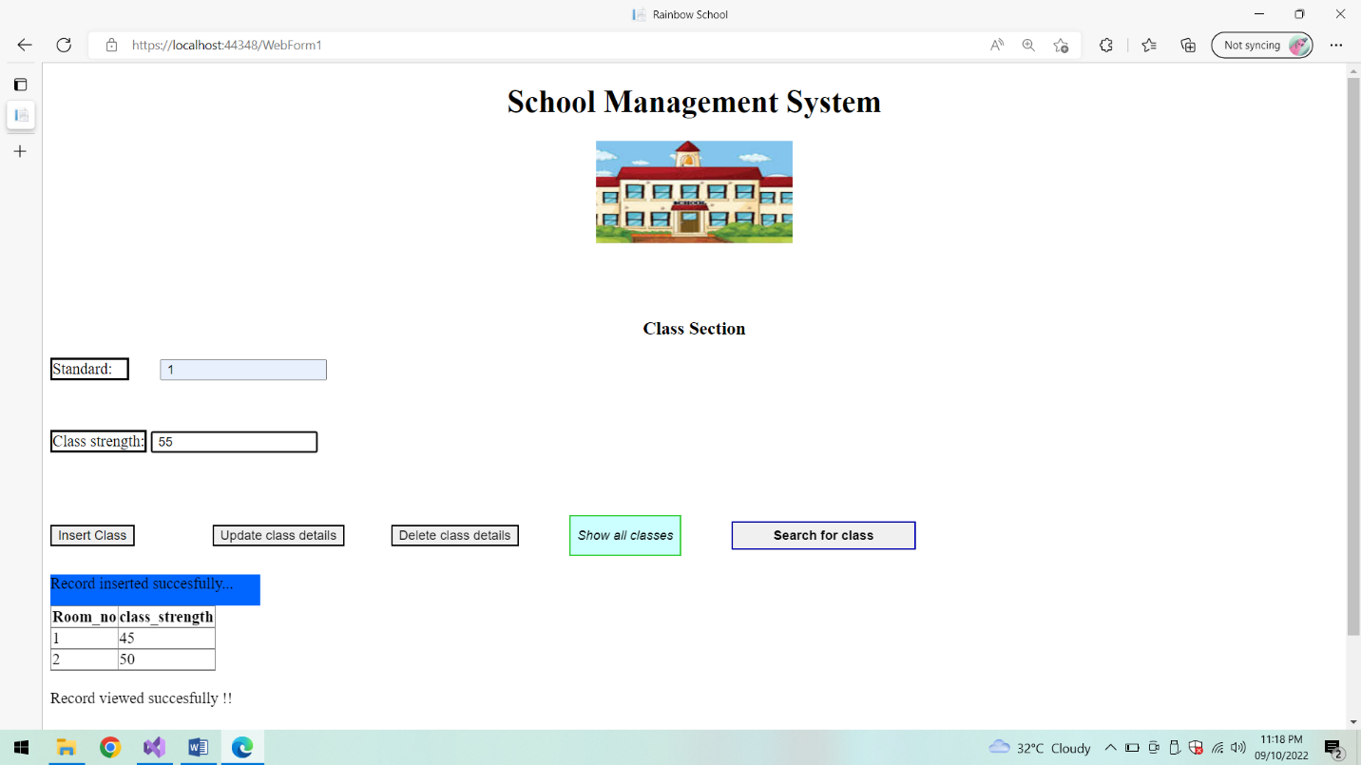

**After updating Message is displayed using Labels:**

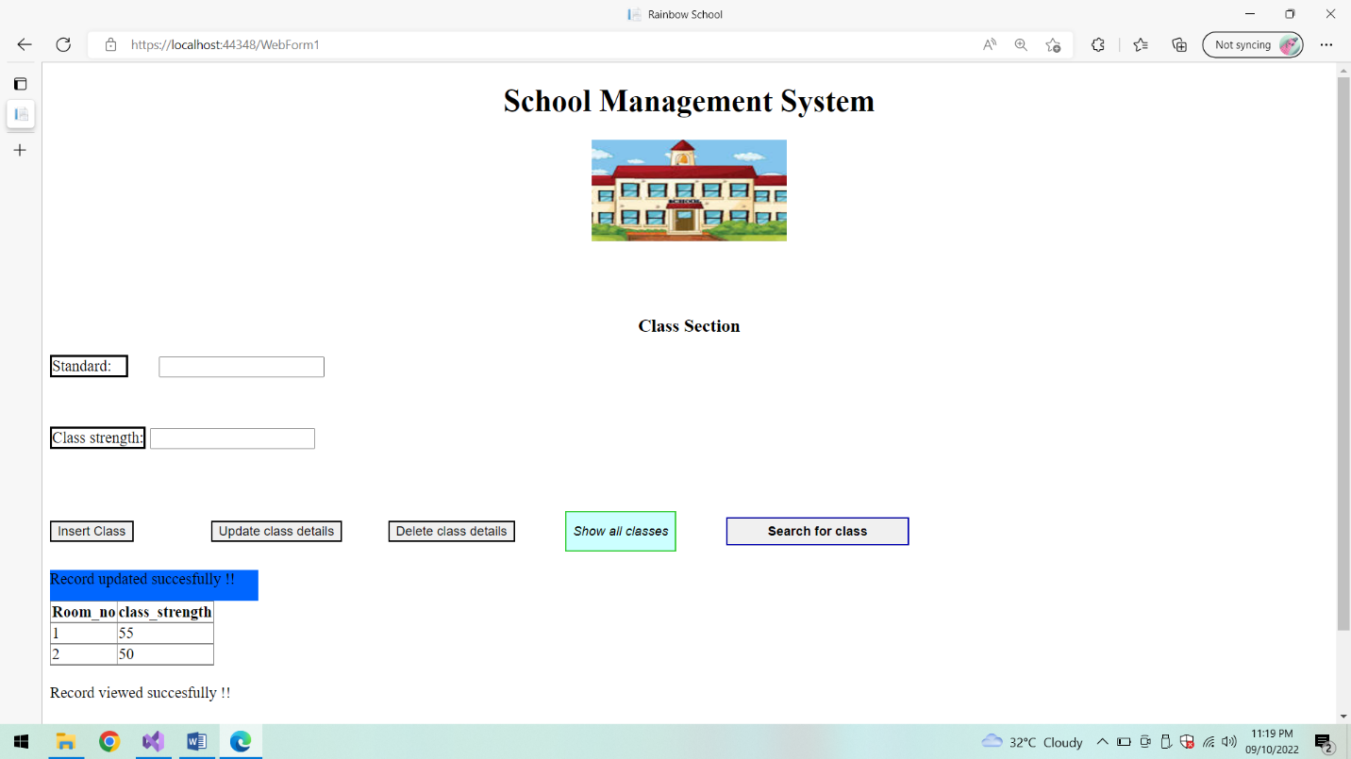

**Delete class:**

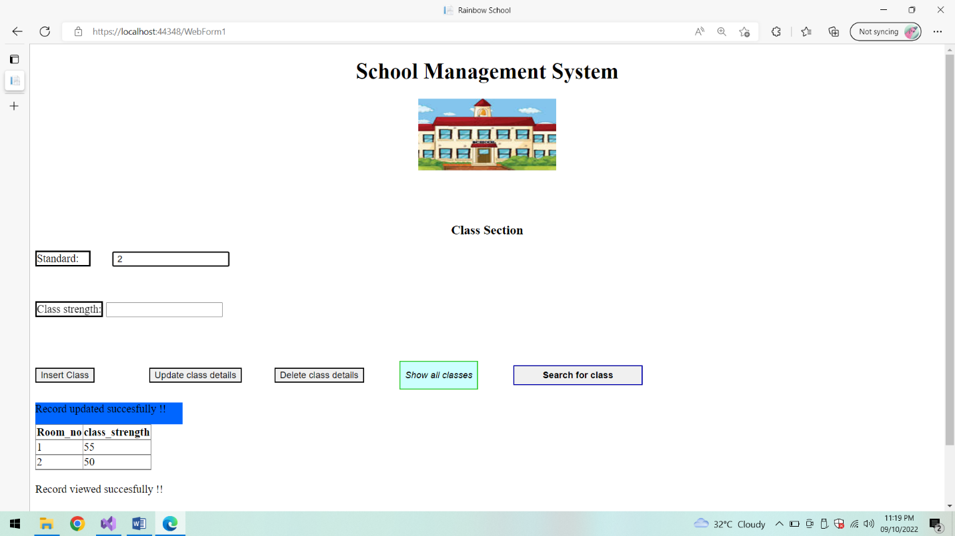

**After deletion List of classes:**

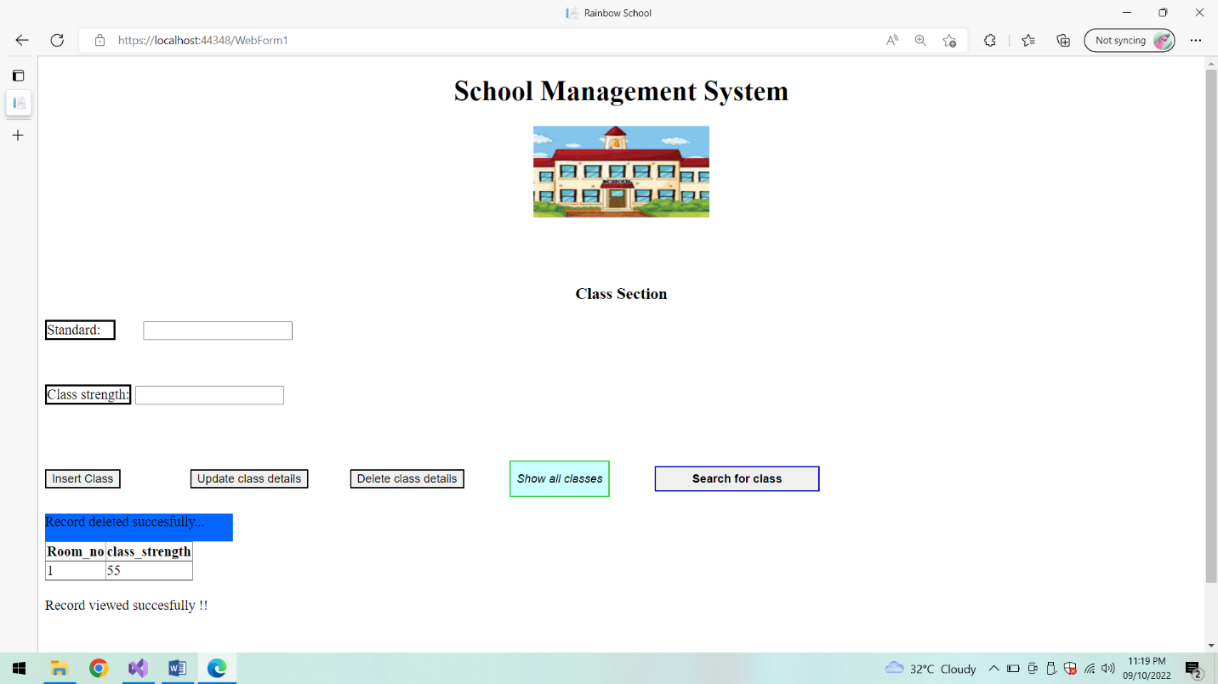

**Search a class using Room_no:**

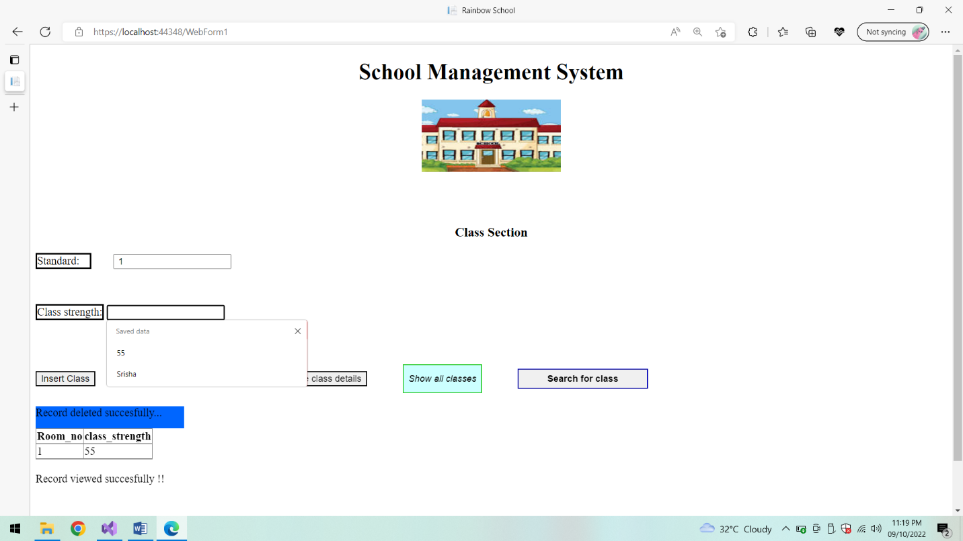

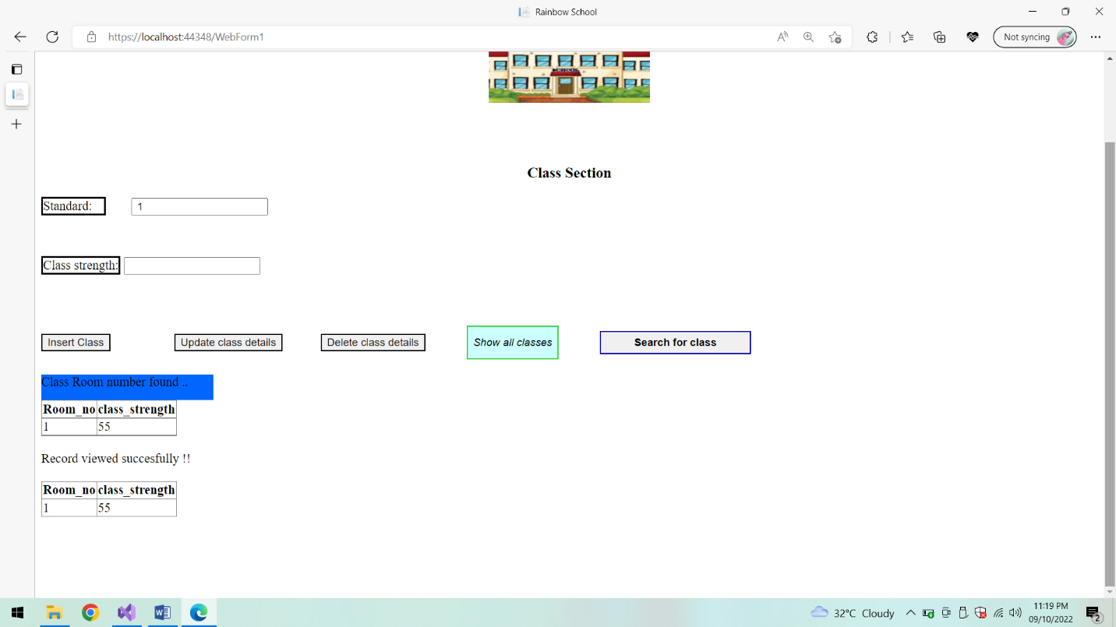

**Student section:**

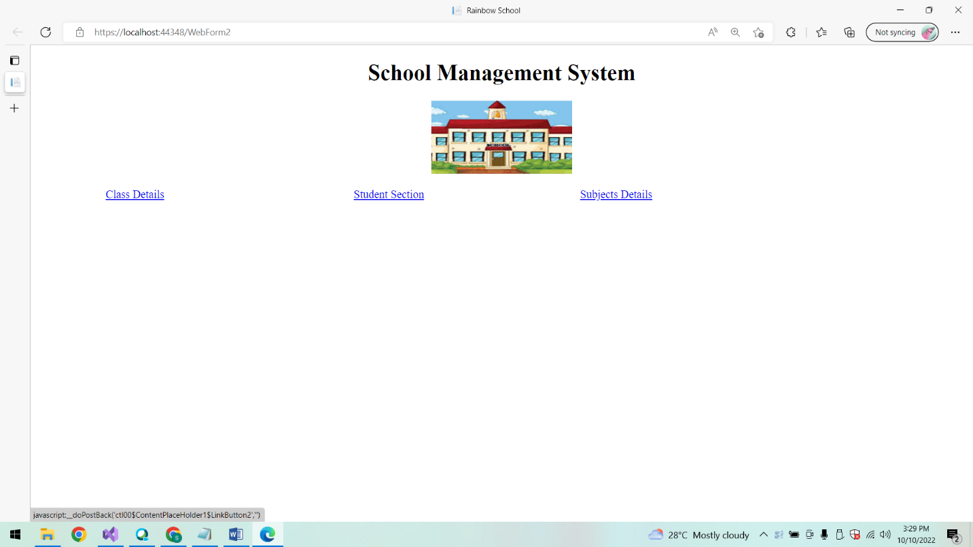

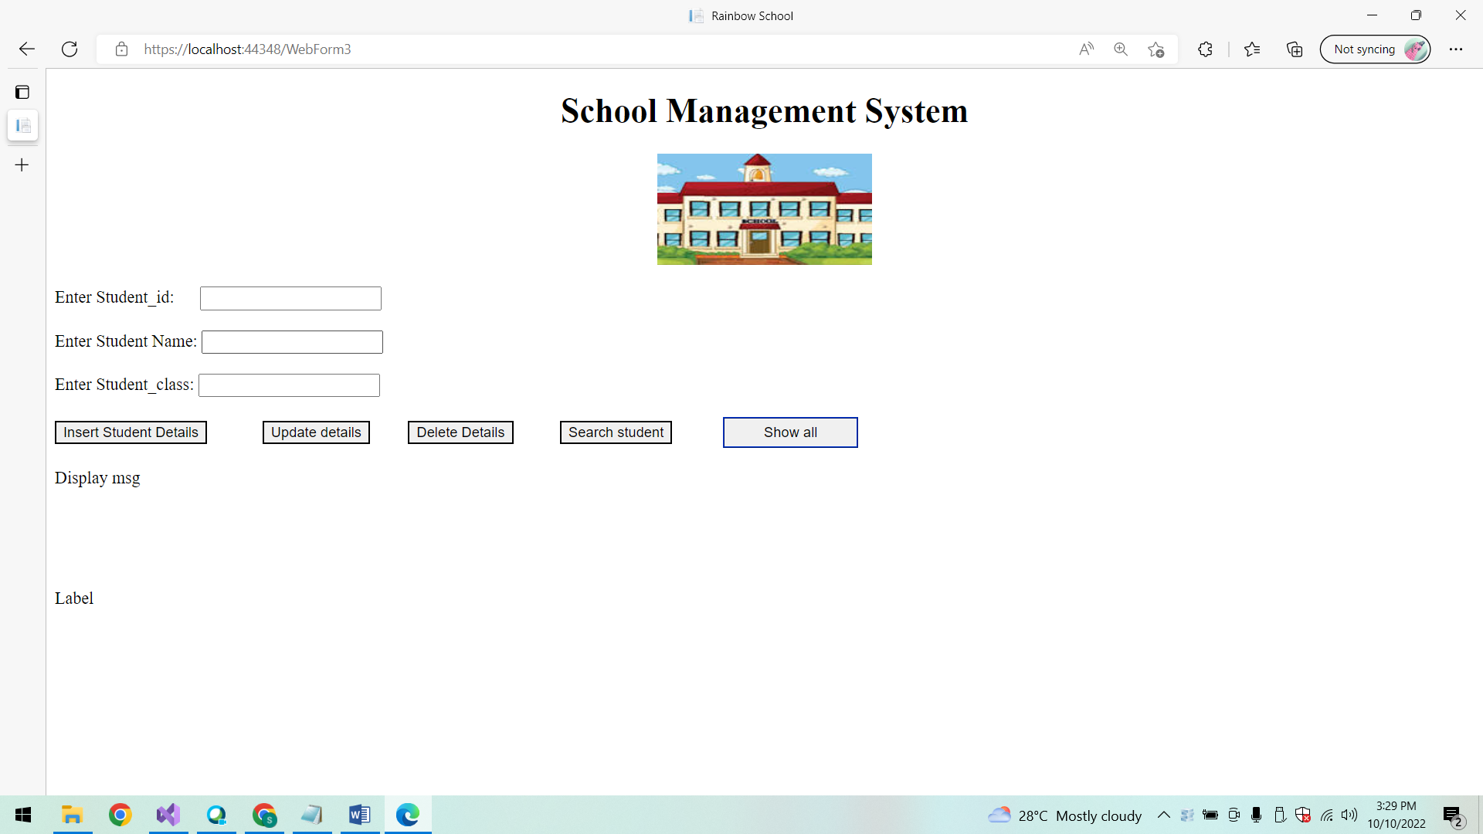

**Show All Students:**

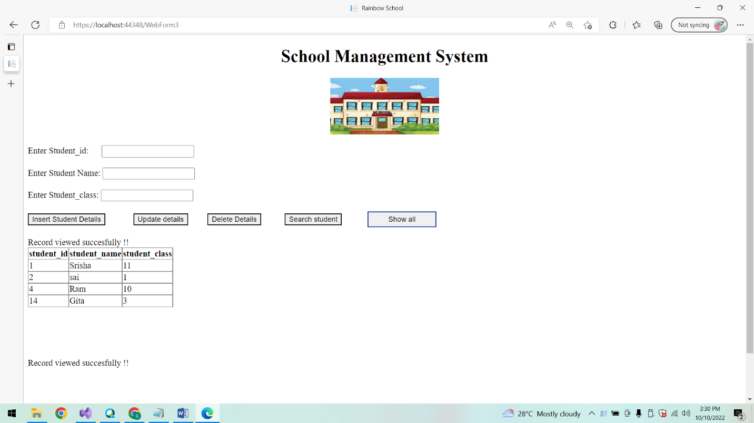

**Insert Student Details:**

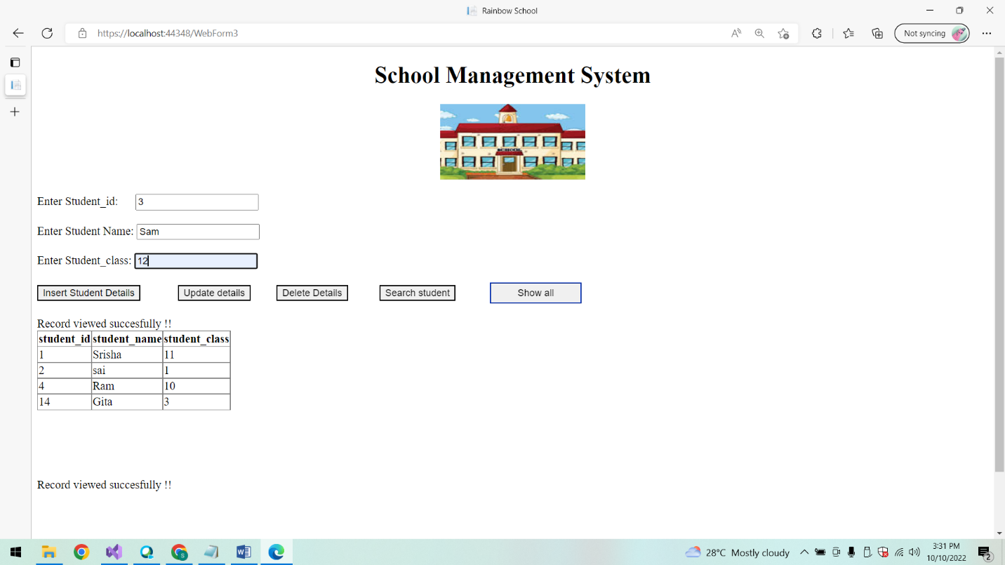

**Show All students:**

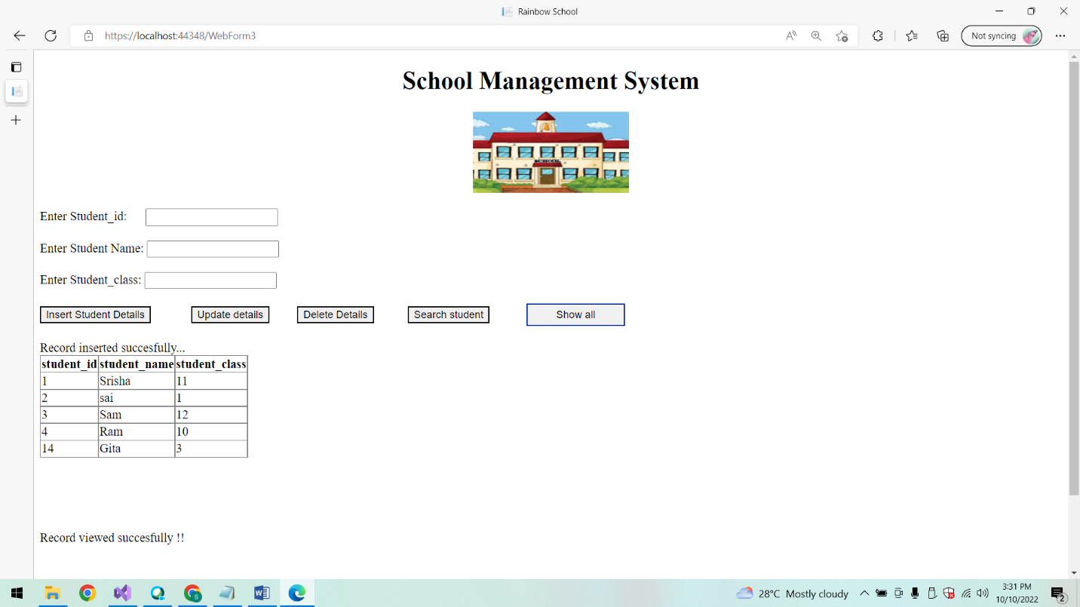

**Update student details:**

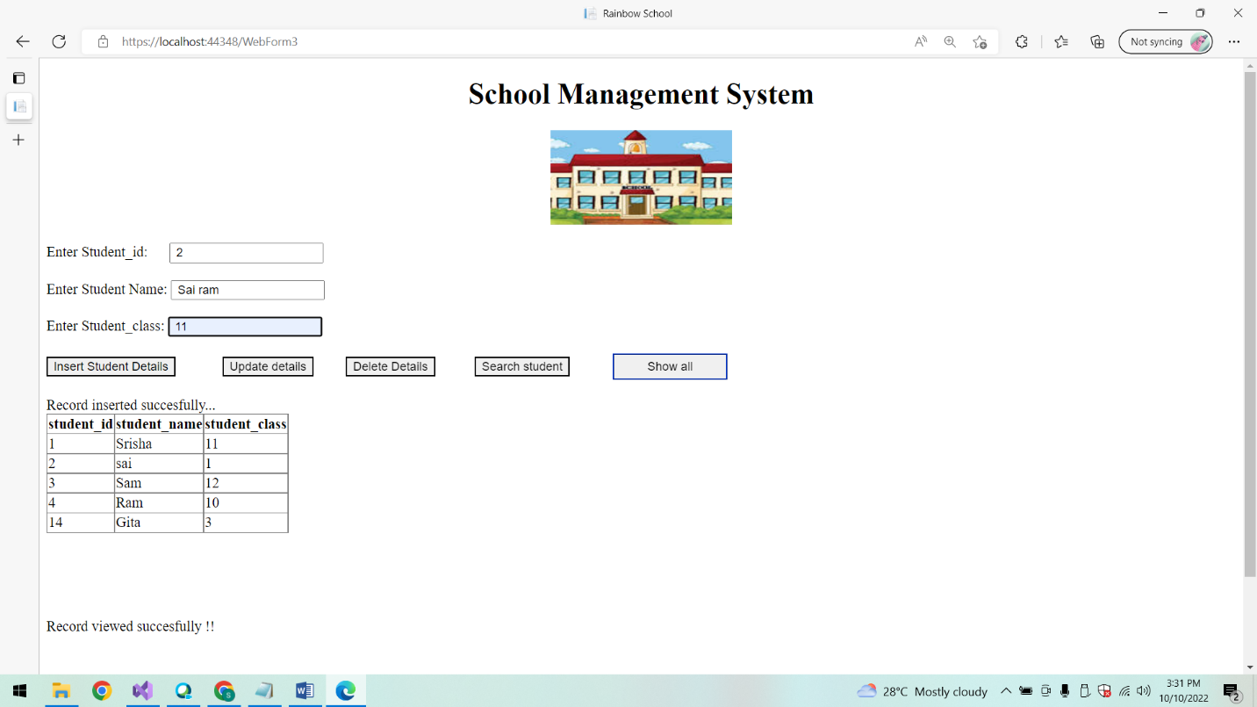

**After updating List of students:**

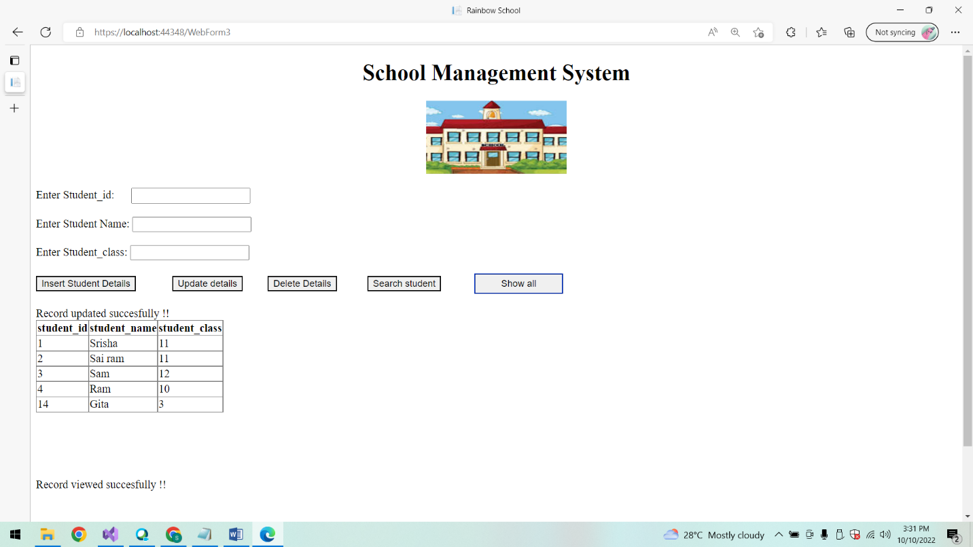

**Delete student:**

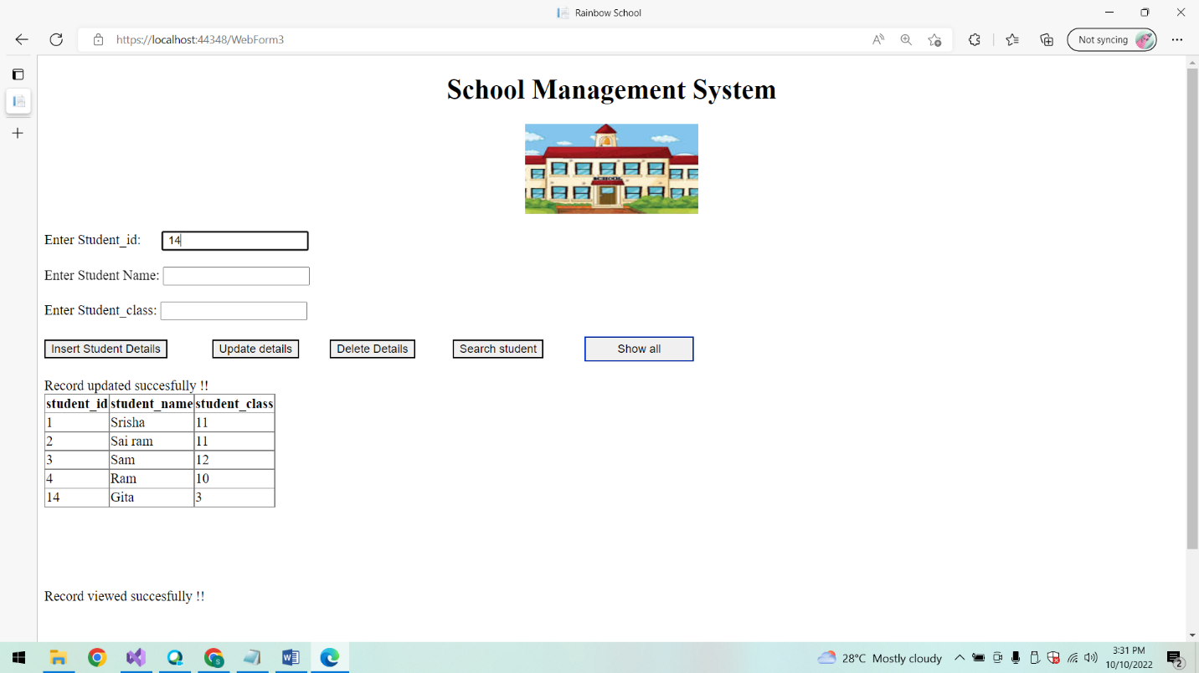

**After deletion List of students:**

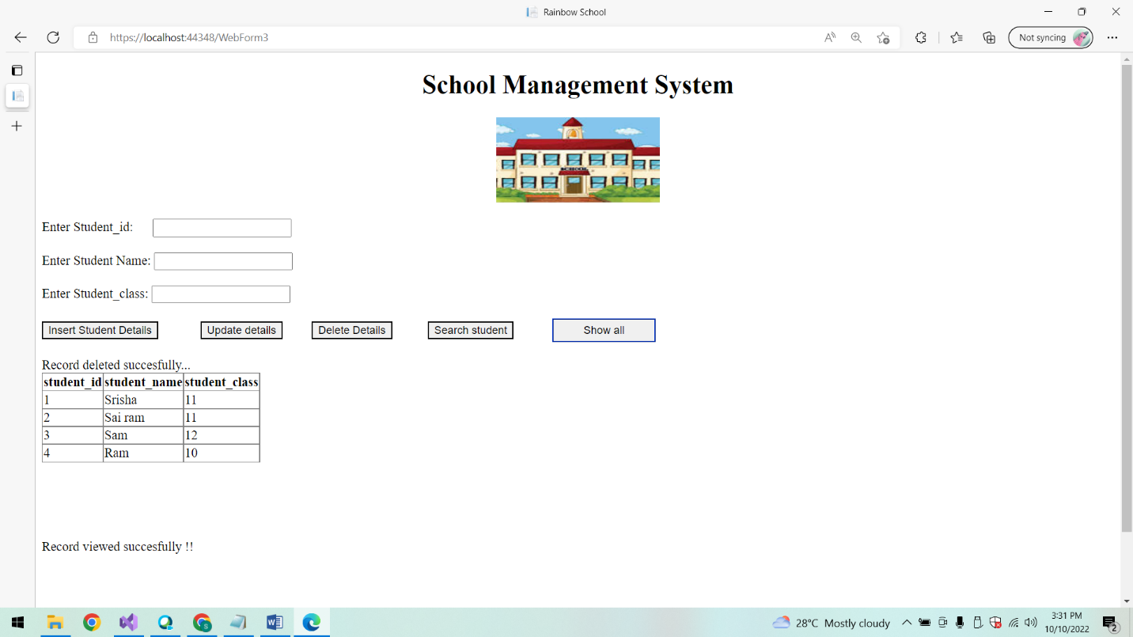

**Search student using student id:**

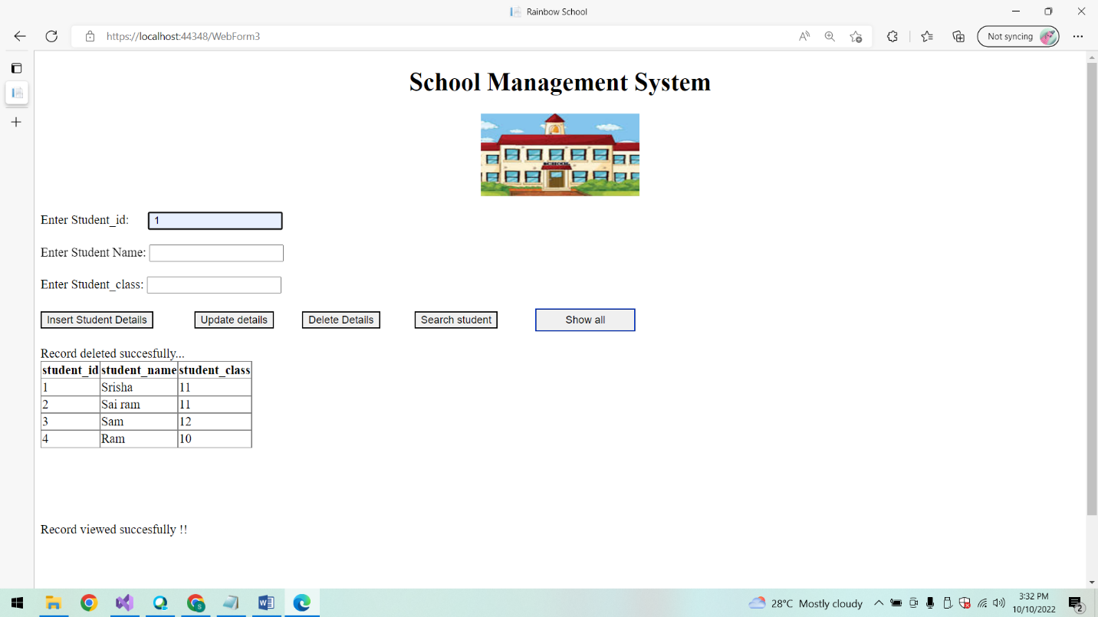

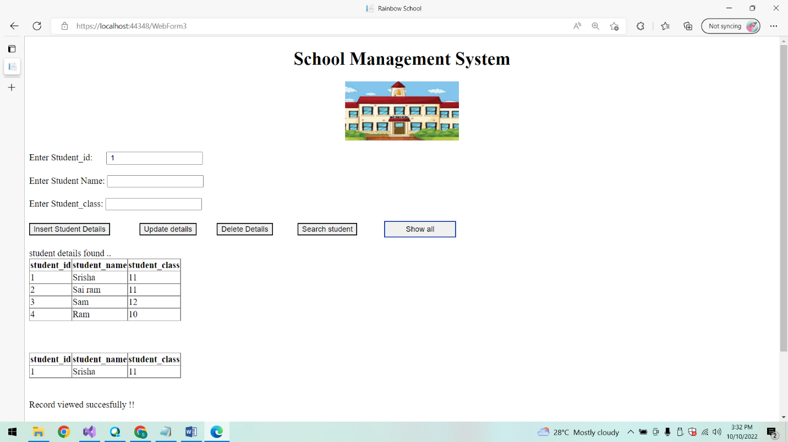

**Subject details:**

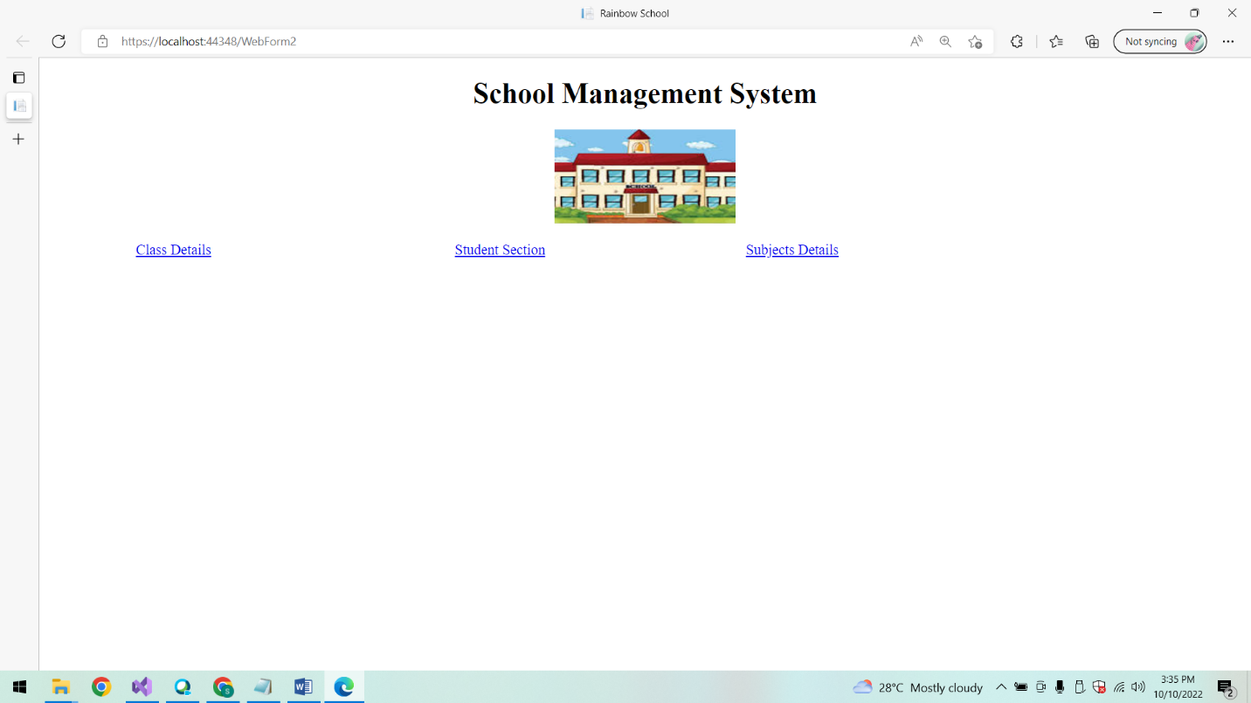

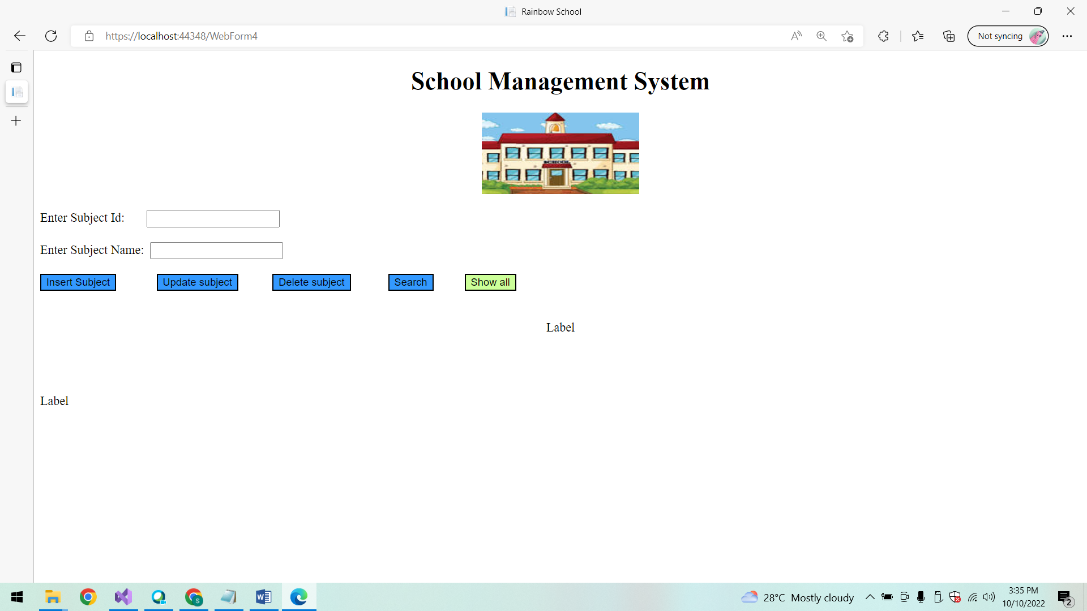

**Show All Subjects:**

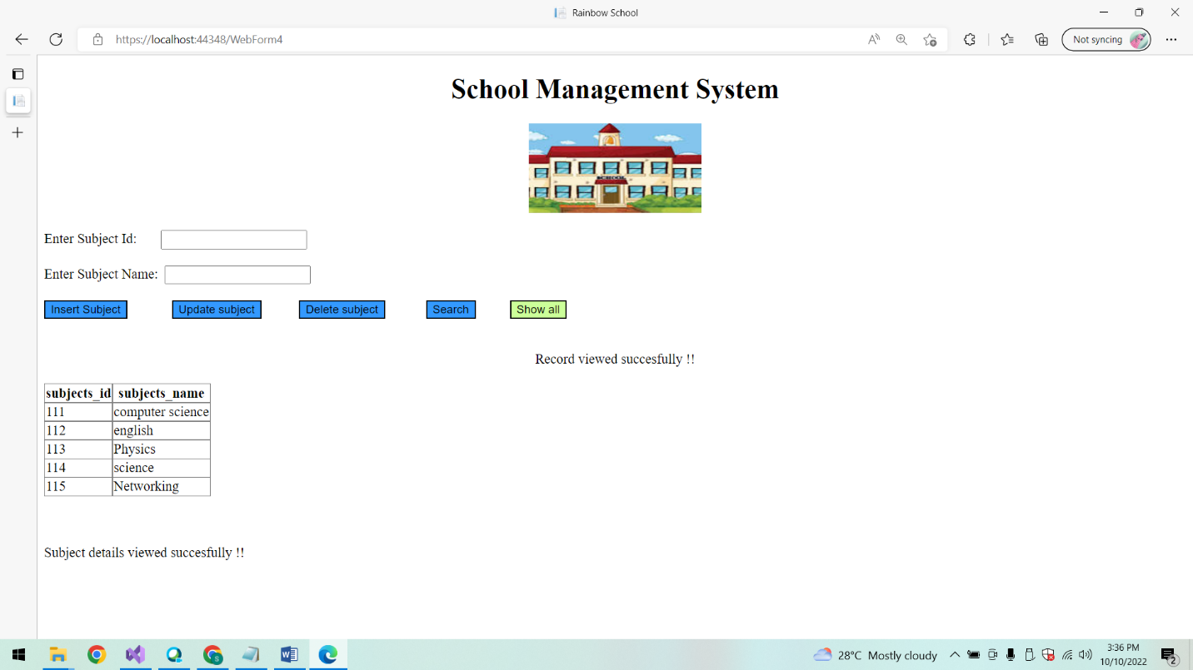

**On clicking Insert Button to Add subject:**

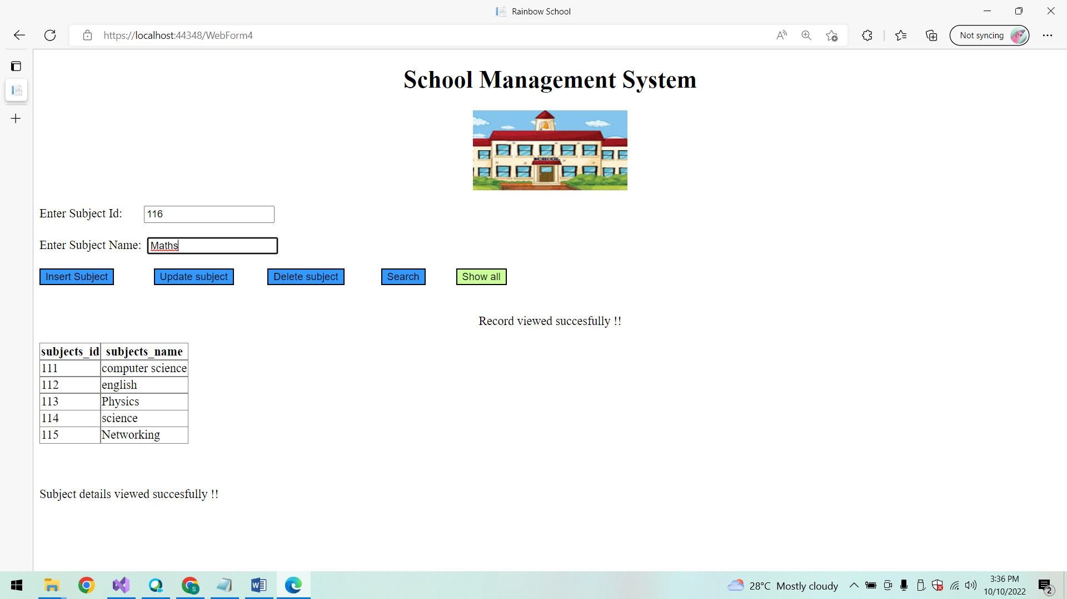

**Show all Subjects:**

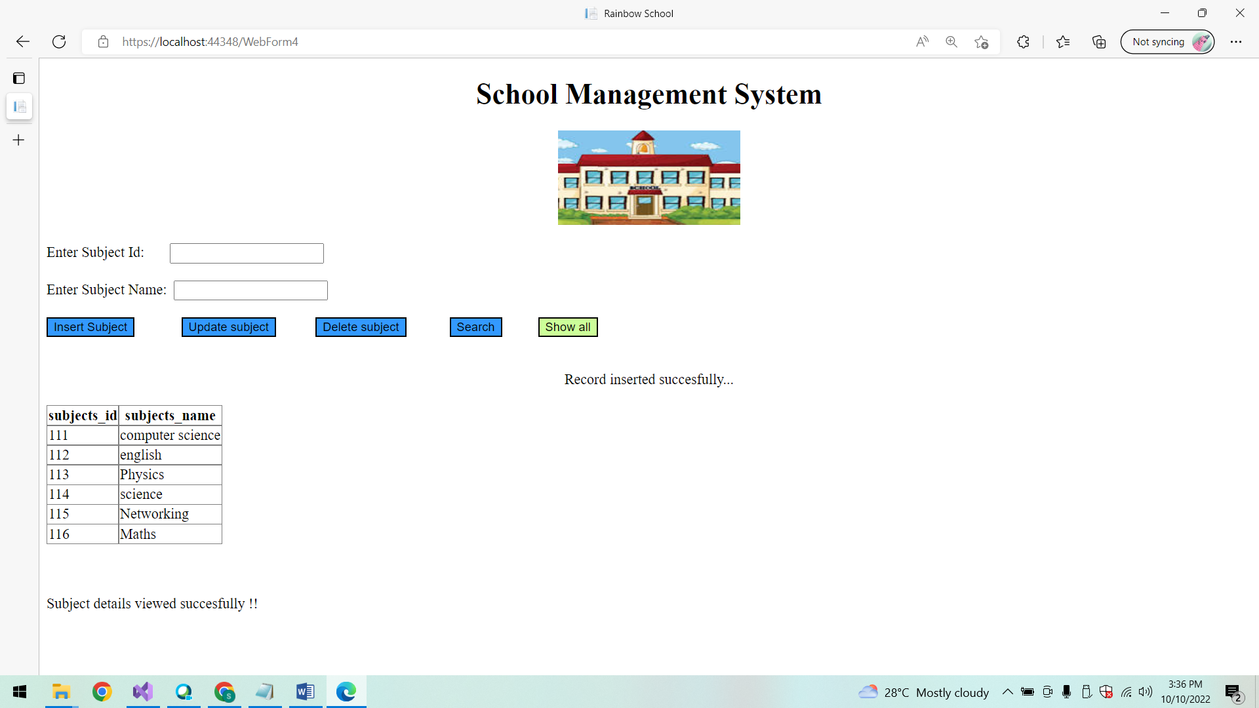

**Update subject details:**

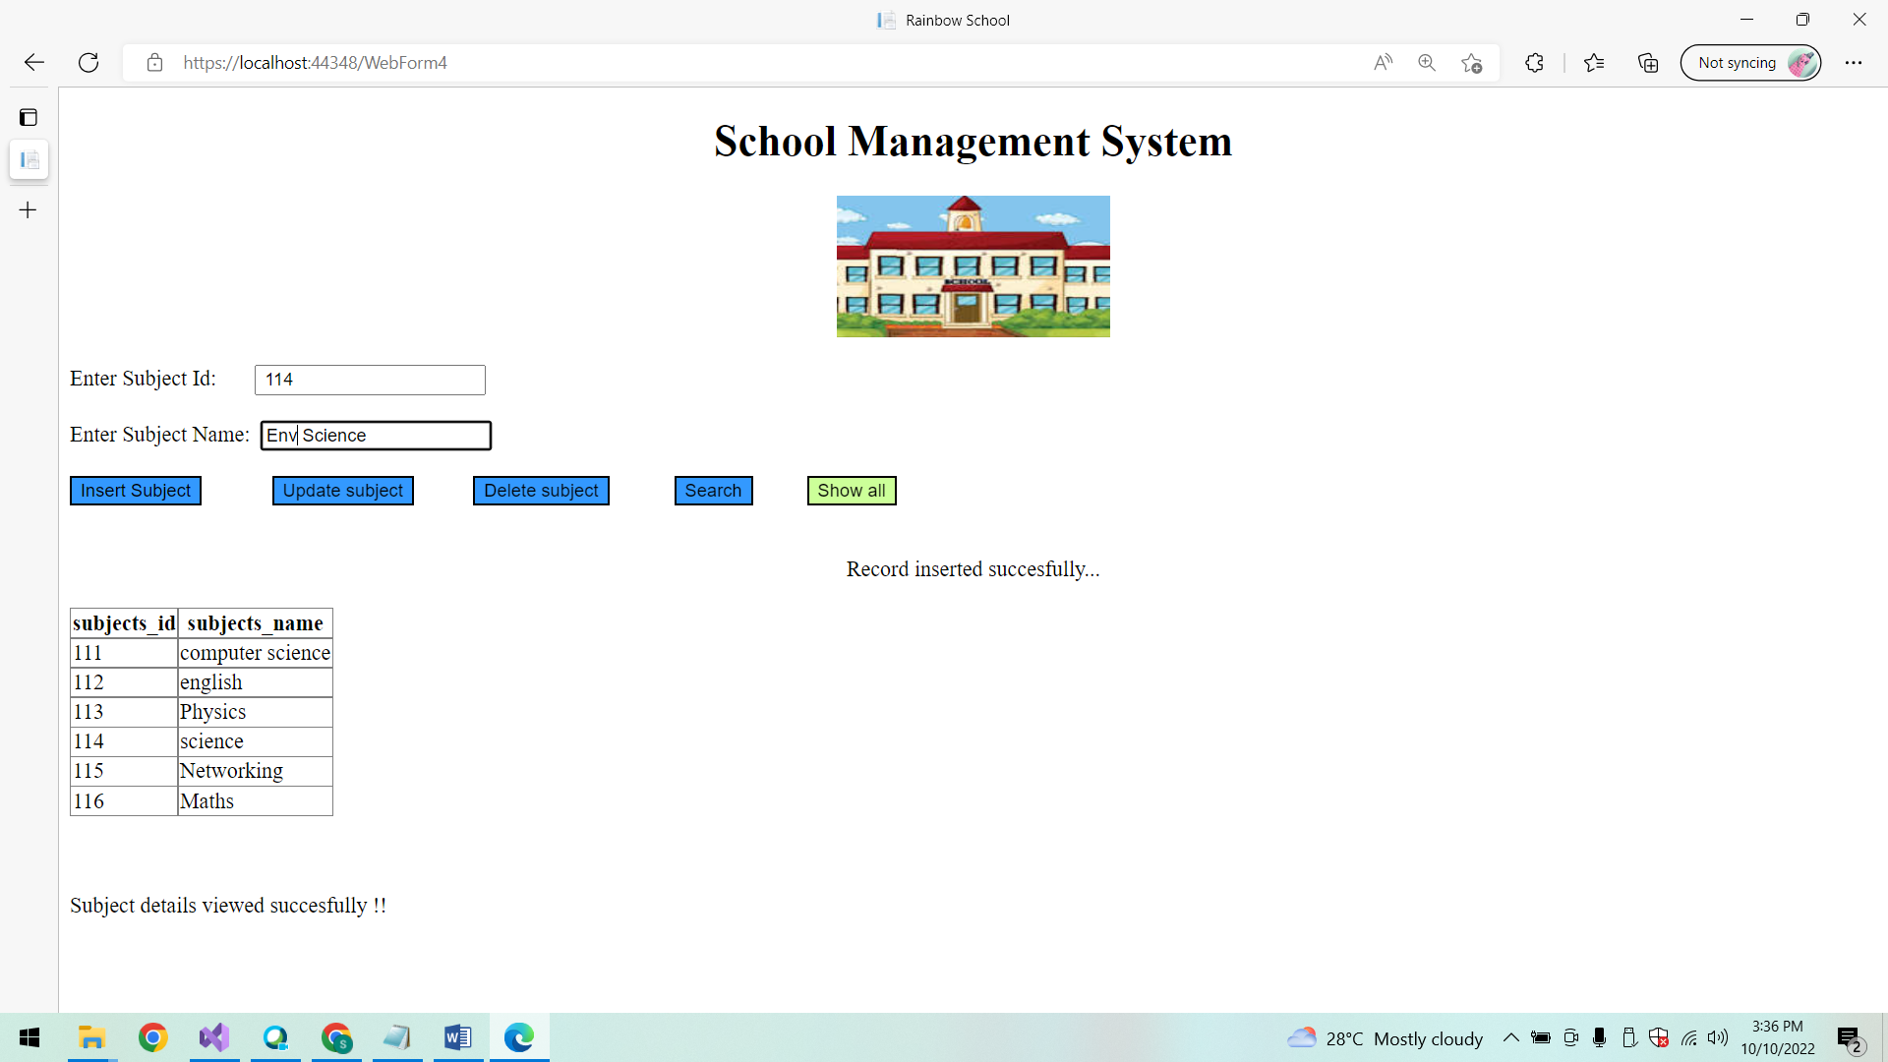

**After Updating List of subjects:**

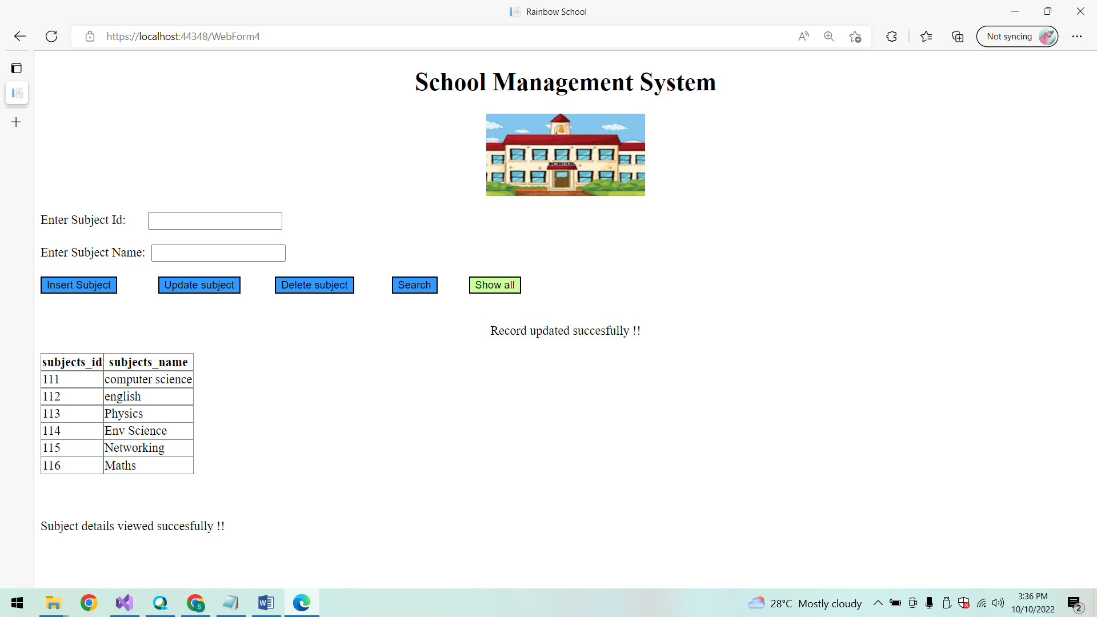

**Delete Subject:**

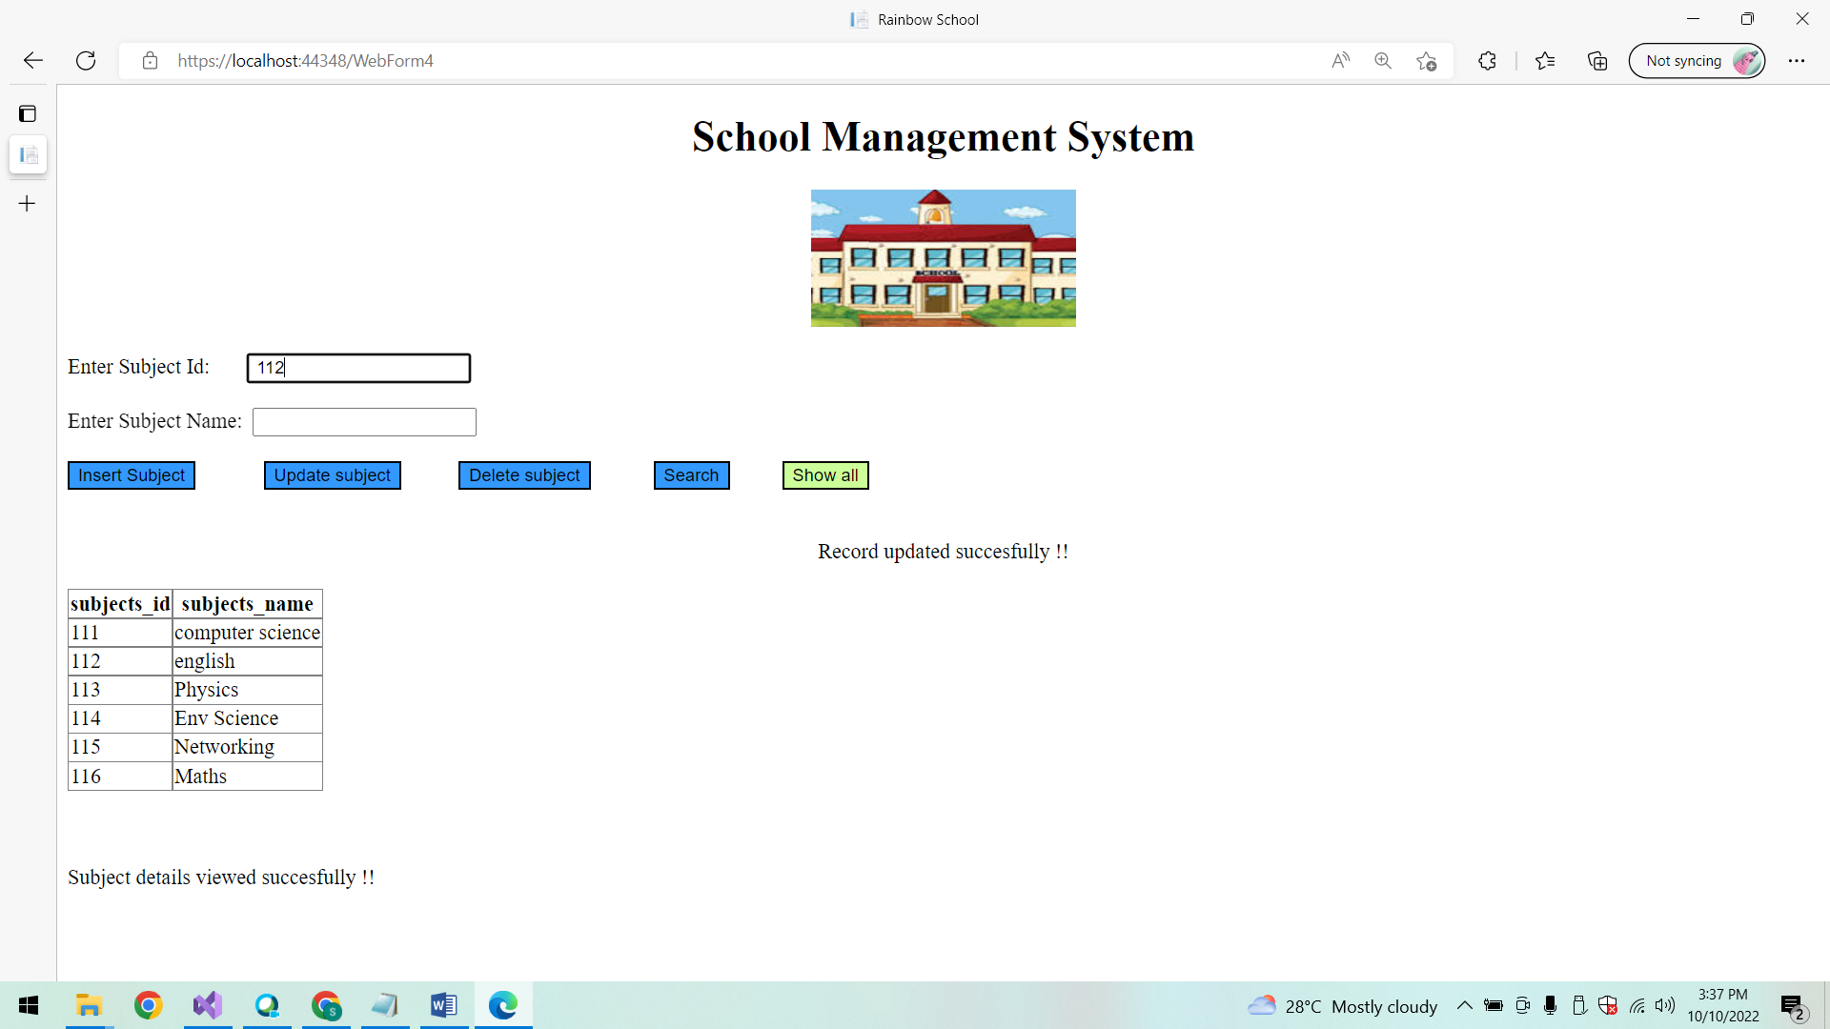

**After deletion List of subjects:**

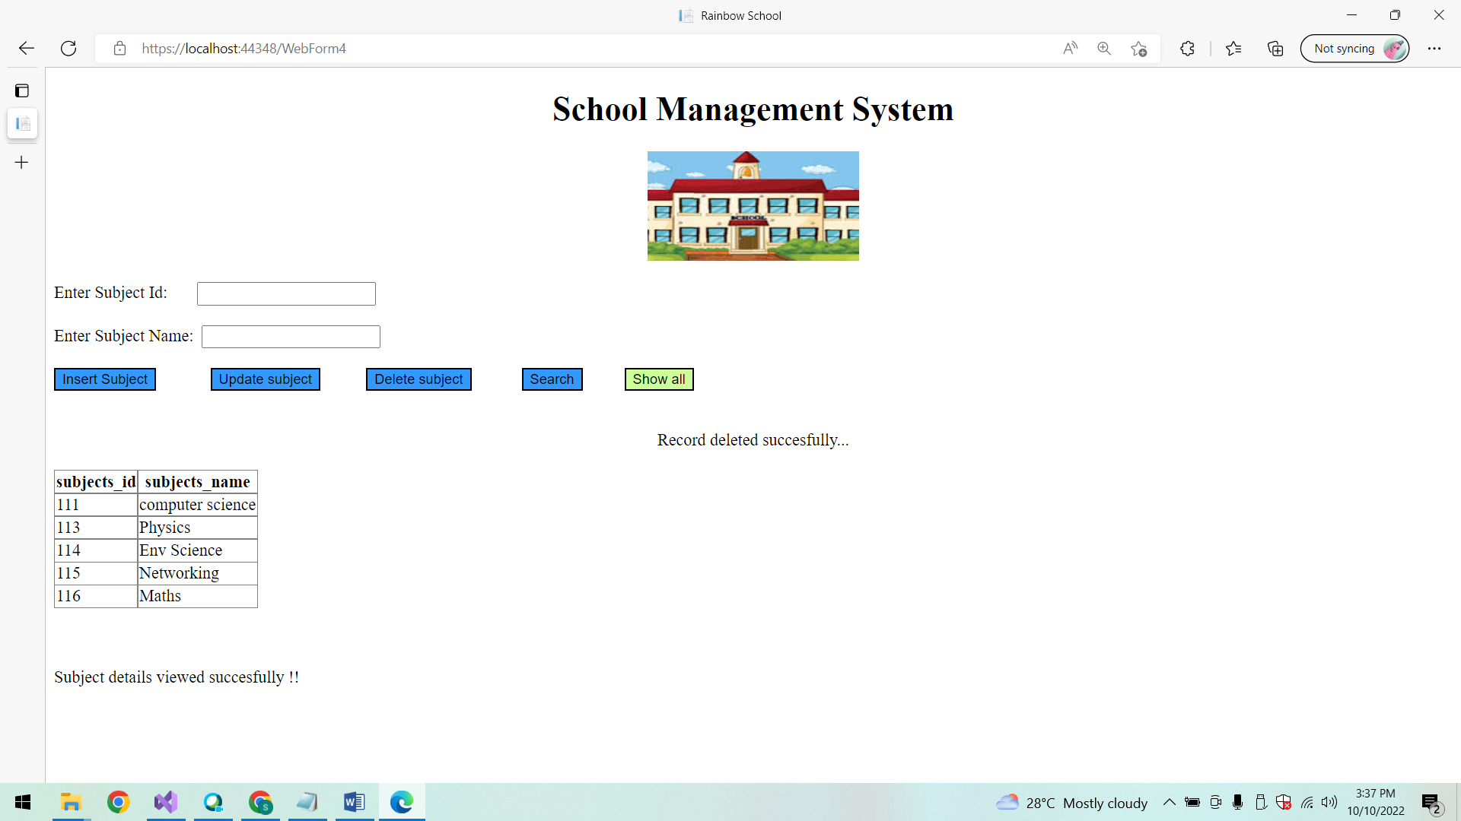

**Search a Subject using Subject id:**

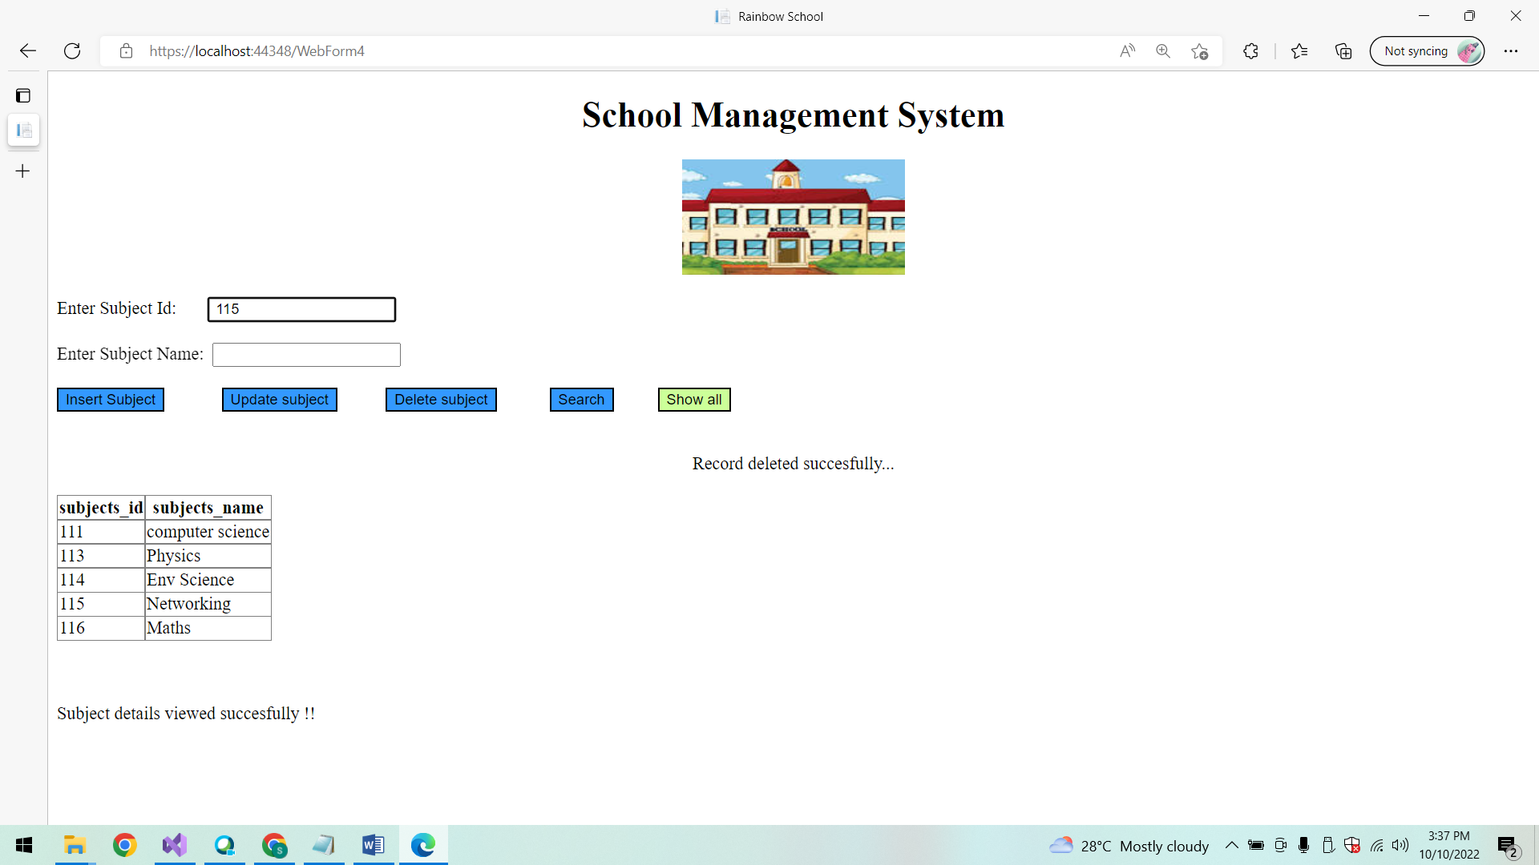

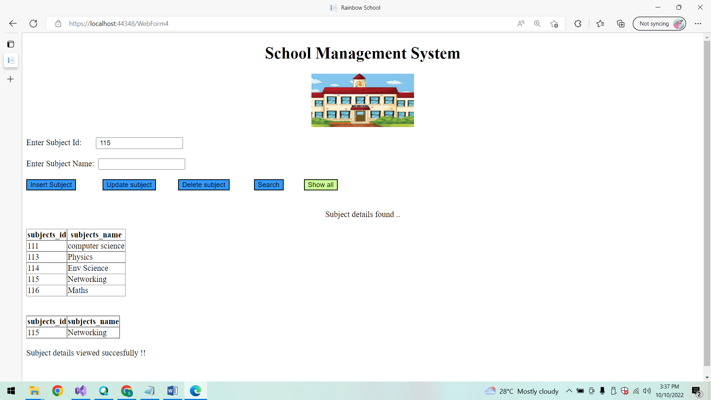

**Conclusion:**

Thus the ASP.NET WebForms application is created successfully.